# Introduction

Brief literature review on ES isometric vs. work-loop/ isotonic ES curves

A.

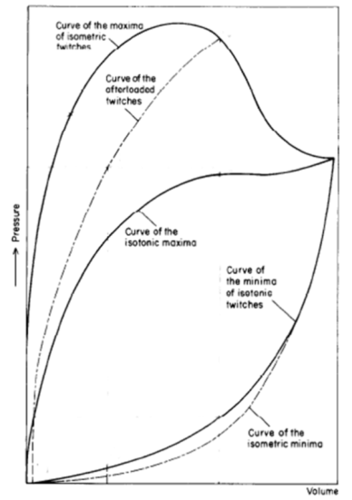

B.

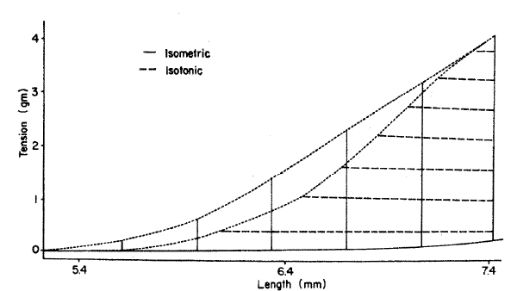

Figure 1

*A: Stylised plot of passive (end-diastolic: lower-most two curved lines) and active (end-systolic: upper-most three curved lines) pressure-volume relationships of excised frog heart. Note the separate end-systolic relationship for isometric (solid line) and afterloaded (broken line) twitches. Modified from Figure 3 of Frank (1899), with permission of the Copyright Clearance Center via RightsLink: License Number 3840330537202. B: Example of the relative difference in end-systolic curves between isometrically and isotonically contracted rabbit papillary muscle. Reproduced from Figure 7 of Brady (1967), with permission of Oxford University Press.*

# Methods

How the model works. Details of the simulations:

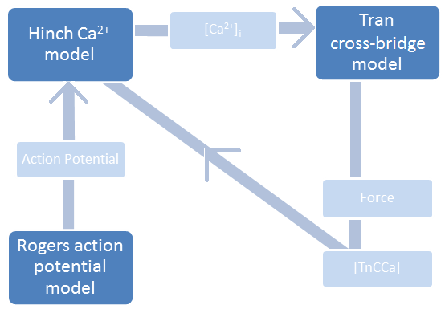

Figure 2

*High-level coupling between the Tran et al.* (2010) *cross-bridge, the Hinch et al.* (2004) *Ca2+, and the Rogers and McCulloch* (1994) *action potential models.* [TnCCa] represents the intracellular concentration of Ca2+ bound to troponin-C.

# Results

Model validation and presenting the figures:

|  |  |
| --- | --- |
| Figure 3 |  |

*Experimental quick-release shortening of ferret papillary muscle (left; (Kurihara & Komukai, 1995)) and the simulated quick-release shortening of a single sarcomere (right).*

There are two, contraction-mode dependent ES curves:



*Figure 4*

*Two distinct, contraction-mode dependent end-systolic curves are an emergent property of the combined model. The Isometric end-systolic curve (grey) lies to the left of the work-loop end-systolic curve (black).*

1. Initial SL affects Ca2+ width (before t=48ms / shortening)
2. While shortening results in more free Ca2+, it only slightly slows the dwindling intracellular Ca2+ concentration (black lines after t=48ms)

The duration of sufficient [Ca2+]I levels determines (along with SL) the proportion of permissive XBs available for force generation. A steeper decrease in intracellular [Ca2+], therefore, impacts the ability of a sarcomere to maintain force during isotonic contraction. (by this logic, inserting WL ca2+ into an isometric contraction should not decrease the max force?). Ca2+ Duration is only in issue in a scenario that requires sustained Ca2+/ force.

1. The value of intracellular [Ca2+] significantly influences the proportion of XBs in a permissive or non-permissive state.

A work-loop contraction requires sustained force. This force is maintained by

1. The overlap fraction as a function of sarcomere length

Given only the end-systolic sarcomere length the end-systolic force can vary greatly (Figure4). There is a mechanism that enables a cardiomyocyte to generate different levels of force for the same sarcomere length. Hence, sarcomere length is not the limiting factor in force production for a work-loop contraction.

Consider the end systolic force and length of a work-loop contraction. The force is affected but not limited by the end systolic length of the shortened sarcomere, for an isometric contraction at this same length generates more force.

Looking at the end-systolic force-length curves, a work-loop contraction generates LESS force than an isometric contraction for most end-systolic sarcomere lengths. In other words, a short sarcomere length is not the limiting factor in determining the end-systolic point

1. The proportion of XBs that move from the permissive state to a force-producing state.

We

It is our hypothesis that, the time-dependent nature of sarcomere shortening places increased significance on the duration of sufficient intracellular ca2+ levels. We think that a lack of intracellular Ca2+ is the determining factor in ES sarcomere length for work-loop contractions. Additionally, we predict that inserting a ‘wider’ isometric Ca2+ transient will allow for further isotonic shortening within work-loops, the end result being a united isometric and work-loop ES curve.



*Figure 5*

*The shape of the intracellular [Ca2+] transient depends on the contraction mode (gray vs. white). Additionally, sarcomere length (for isometric contractions-grey) and afterload (for work-loop contractions-black) affect the width of the intracellular [Ca2+] transient*

The lack of free [Ca2+] is the determining factor in the location of the ES point. The number of potential XBs in the thick/ thin filament overlap would allow for the generation of force sufficient for continued shortening, but the lack of free [Ca2+] causes the sarcomere to stop shortening ‘prematurely’.

To test our hypothesis, we insert isometric Ca2+ transients into WL contractions: The results is a leftward shift of the ES curve



*Figure 6*





We can Unite the ES curves:



*Figure 7*

# Discussion



